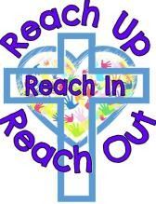
Bluebell Curriculum Overview 2026-27

Autumn 1 | KS1 Text | EYFS Text | SEN | KS1 Topic | EYFS Topic/song | RE/Music
Week 1 | The Colour Monster Goes to School  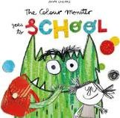  T1  Colour  Monster  Happy  Sad  Angry  Scared  Calm  Friend  Feelings  Smile  T2  Emotion  Confused  Identify  Organize  Frustrated  Peaceful  Express  recognise |  | Sensory story – Pets  Themed bucket time  - Globe/world  - Animal groupings  - Drawing  - Food tasting/exploration | All about me | All about me/pets  Heads/shoulders | Music –  Anyone can play  My Musical Heart Beat  RE -  Unit 1:2 – What do people believe about how the world began?
Week 2 | Wanted! Perfect Pet  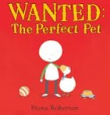  T1  Cage  Home  Clean  Love  Happy  Sad  T2  Perfect  Responsibility  Gentle  Energetic  Loyal  Affection  companionship | Information – Pets |  | Geography – Continents and oceans | All about me/Pets  Sticky kids – hands on hips
Week 3 |  |  |  |  | Houses/Homes  Sticky kids – I jump out of bed
Week 4 |  | Goldilocks and the 3 Bears  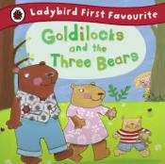  T1  Tiny Little Bright Early Naughty Lumpy Empty Full  Hard Soft cross  T2  Deep Golden Rosy Puckish while/so suddenly crash smash peeked  hurried meanwhile |  | Art – Explore and draw  (EYFS – Jackson Pollock) | Houses/Homes  Goldilock’s Rap
Week 5 |  |  |  |  | Bears  Bear went over the mountain
Week 6 | Non chron – Pets | Bears – Information text  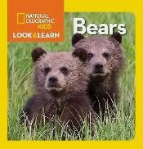  T1  Giant Round Cold spots  T2  Fur Hunting Paws Paddle |  | Computing – Y1 data and information | Exploring musical instruments  I am the music man
Week 7 | Non chron – Pets |  |  | DT – Food and nutrition | Food  1 tomato BBC
Week 8 | Poems on a theme (rhymes)  1,2 buckle shoe  Ring o roses | Ketchup on your cornflakes - Espresso |  | Re-visit week/Trip (science link)
Science | Animals including humans
PSHE | Story Project
Revisit opportunities | PSHE – My Happy Mind  Computing – How to log on, looking after tech  Geography – Countries of the UK  Science – Looking after our bodies  DT – Healthy eating plate/chopping skills  Art - Spirals

Autumn 2 | KS1 Text | EYFS Text | SEN | KS1 Topic | EYFS Topic/song | RE/Music
Week 1 | Pumpkin Soup (non-fiction)  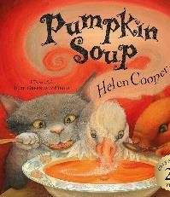  T1  Pumpkin  Soup  Forest  Kitchen  Spoon  Fire  Cook  Stir  T2  Ingredients  Recipe  Tradition  Disagreement  Reluctant  Compromise  persuade | Little Red Hen  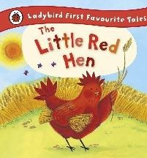  scratching excited  snorted  preening  snoozing mumbled  sneaky  gleeful  delicious  greedy  T2  Effort  Harvest  Responsibility  Co-operate  Contribute  Industrious  Refuse  Persistent  selfish | Sensory story – Little red hen or Autumn  Themed bucket time  - Fire  - Fireworks  - Poppies  - Toys old and new  - Nativity  - Plants  - Christmas | Art – cross curricular drawing (bonfire/Diwali/poppies) | Diwali/bonfire  Wanderlust – darkness  Twinkle Twinkle | RE –  Unit 2:2 Why do Christians believe the birth of Jesus was such good news?  Music – Choosing instruments  Dance, sing, play
Week 2 |  |  |  | History - Toys | Wanderlust – fire  Poppies  Cbeebies – firework song
Week 3 |  | Rapunzel  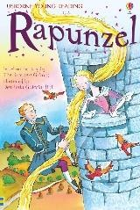  locked golden beautiful escape through happily  palace  T2  Imprisoned  Enchanted  Lonely  Curious  Desperate  Escape  Discover  Journey  sorrow |  | History - Toys | Toys  1, 2, 3, 4, 5
Week 4 | The Enormous Turnip  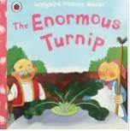  T1  Enormous  Turnip  Man  Woman  Child  Garden  Plant  Pull  Grow  Y2  Teamwork  Stubborn  Effort  Strength  Succeed  Perseverance  Harvest  depend |  |  | Re-visit | Toys  Little Donkey
Week 5 |  | Stick Man  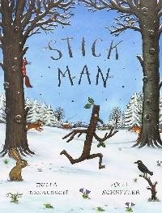  T1  Stick  Tree  Branch  Family  River  Sea  Snow  Nest  T2  Adventure  Journey  Separated  Exhausted  Rescue  Search  wander |  | Nativity | PEEPO! My family now/past  Jingle Bells
Week 6 |  |  |  | Nativity | Marmaduke – dragon (PSED)  Away in a Manger
Week 7 | Poems  12 Days of Christmas |  |  | Christmas
Science | Plants including trees
Computing | Y1 - beebots
PSHE | Story Project
Revisit opportunities | History/DT – Great fire of London  Art – Playful making – sculpture  Science – Plants/seasonal change and weather

Spring 1 | KS1 Text | EYFS Text | SEN | KS1 Topic | EYFS Topic/song | RE/Music
Week 1 | Supertato | Snow Thief  T1  Bird  Squirrel  Tree  Cold  Snow  Ice  Winter  Snowflake  Ground  Friend  T2  Disappear  Investigate  Puzzled  Notice  Explain  Discover  Melt  Worried  Search  Change | Sensory story – Winter snow  Themed bucket time  - Hot and cold  - Painting  - Materials | Geography – Hot and Cold Places | Winter  Running in the rain – sticky kids | Music –  Intro loud and quiet  Exploring sounds  RE – Unit 15 Who is a Muslim and how do they live? Part 1
Week 2 |  |  |  |  | Northern Lights – wanderlust  The north wind doth blow
Week 3 | Supertato | Storm Whale  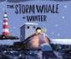  rescued  ashore  glimpse  dashed  dragged clambered |  | Art – Expressive painting  Re-visit | Dogger - history  Sticky kids – music song
Week 4 |  |  |  |  | Habitats  Sticky kids – rhythm sticks
Week 5 | Supertato | Superworm  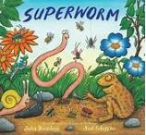  T1  cheer Super Strong Squirm scared magic cross  T2  disaster mope panic chant bored lair mutters fearful |  | Computing – Digital writing | Habitats  There’s a worm at the bottom of the garden
Week 6 | Supertato |  |  | Re-visit week | Chinese New Year
Science | Everyday materials
PSHE | Story Project
Revisit opportunities | Geography – Nairobi/Yanomami  Art – Printing

Spring 2 | KS1 Text | EYFS Text | SEN | KS1 Topic | EYFS Topic/song | RE/Music
Week 1 | Bob Man on the Moon | Whatever Next  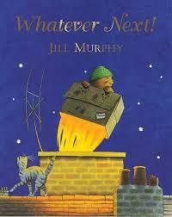  draining-board journey passengers boring dripped state | Sensory story – Whatever Next or Spring  Themed bucket time  - Space  - Eid  - Painting  - Waterproof objects  - Holi  - Easter | History – Explorers | Famous People – Helen Sharman  5 little men in a flying saucer | RE  Unit 2:4 Why does Easter matter to Christians?  Music – Contrast  Learning to listen
Week 2 |  |  |  |  | Amelia Earhart  Mix a Pancake
Week 3 | Bob Man on the Moon | The Most Exciting Eid  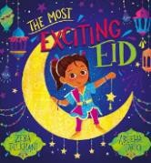  Eid al fitr henna attic gathering outfit streamers Bunting  Eid mubarak |  | Art – Cross curricular painting | Eid  Eid rhyme (wheels on bus tune)
Week 4 | Bob Man on the Moon |  |  | DT - Materials | Rainbows  I can sing a rainbow
Week 5 | Assessments | Tadpole’s Promise  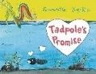  Tiny Shiny Grown Change Warm Love  Fluttered  T2  Promise Forgive Beautiful Seasons Twice moonlit  fluttered |  | Re-visit/Easter | Holi/Easter  Mm went the little green frog
Science | Plants inc trees revisit
Computing | Y2 Beebots
PSHE | Story Project
Revisit opportunities | History – Our village  DT – wheels and axles/junk modelling

Summer 1 | KS1 Text | EYFS Text | SEN | KS1 Topic | EYFS Topic/song | RE/Music
Week 1 | The True Story of 3 Little Pigs | 3 Little Pigs  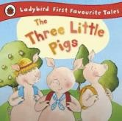  T1  Bad Big Little Tasty Heavy First High  Second Roared juicy  T2  Brave Bold Bad  Before long Load Meanwhile Creeping Squeaked Next Gather  Planned | Sensory story – 3 Little Pigs  Themed bucket time  - Sticks/materials  - Maps, exploration  - Clothing/fabrics  - Science cause and effect | Art – Stick Transformation | Junk modelling  Who’s afraid of the big bad wolf | RE –  Unit 17  Who is a Muslim and how do they live? Part 2  Music – Shake tap ring  Having fun with improvisation
Week 2 |  |  |  |  | 3D sculpture  It’s raining
Week 3 | The True Story of 3 Little Pigs | Billy Goat’s Gruff or Little \red |  | Geography – Maps | Transport  I hear thunder
Week 4 |  |  |  |  | Transport  Mary Mary
Week 5 | The True Story of 3 Little Pigs | Magic Porridge Pot  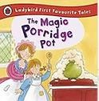  felt wept sob kind  overjoyed  dreamy creamy bubble/burb le |  | DT - Textiles | History – dinosaurs  Dinosaur song bbc
Week 6 | The True Story of 3 Little Pigs |  |  | Computing - Y2 pictograms | History – dinosaurs  Dinosaur song – sticky kids
Week 7 | The True Story of 3 Little Pigs | Tyrannosaurus Drip  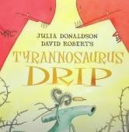  Grizzly Muttered Invented Murmured Thrilled Terror jaws |  | Revisit week
Science | Working Scientifically/Revisit
PSHE | Story Project
Revisit opportunities | Geography - Maps  Art –  DT -

Summer 2 | KS1 Text | EYFS Text | SEN | KS1 Topic | EYFS Topic/song | RE/Music
Week 1 | Aladdin | Brown Bear, Brown Bear  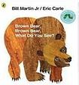  Looking Colours Bear Bird Duck Horse Frog Cat God Sheep goldish teacher | Sensory story – Summer  Themed bucket time  - Educational visit link  - Drawing  - Summer | History – Educational visit link | History – educational visit link | RE –  Unit 1:6 What can we learn from this story?  Music  Composition  Let’s perform together
Week 2 |  |  |  |  | A girl called Mary text
Week 3 | Aladdin | Hairy McClairy  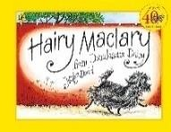  dairy bundle covered trotted snooped clatter scatter |  | Art – Cross curricular drawing | Somone swallowed Stanley - geog
Week 4 | Aladdin |  |  | Performance
Week 5 | Aladdin | Duck in the Truck  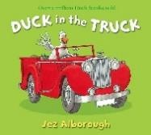  struck muck yucky spies croaks relaxing  gripping
Week 6 | Aladdin |  |  | Summer
Science | Plants including trees revisit
Computing | Digital painting
PSHE | Story Project
Revisit opportunities | Whole Year Learning recap

